

Academic Task Number: 2 Course code: CSE224

**Date of allotment:** 16th Dec 2025 **Course title:** Fundamentals of Android

**Date of submission:** 23th Dec 2025 **Maximum Marks:** 30

Academic Task Type: CA**2**

Student Name: Batsaikhan Narangerel

Roll No:12

Registration Number:12327076

Section:KO007

Subject:CSE-224

Teacher Name: Siya Thakur

Github link: <https://github.com/bat379/CSE224_CA2/tree/main>

|  |  |  |  |  |
| --- | --- | --- | --- | --- |
| **Question Number** | **Question Statement** | **Course Outcome** | **Bloom’s**  **level** | **Marks per Question** |
| Q1 | Design and implement a **Signup Form using Jetpack Compose** with:   * TextField for **Username** and **Password** * **Radio Buttons** for **User Type** (Student / Admin) * **Switch** to enable **Dark Mode** using **Modifier** (Black background when ON, White background when OFF) * Signup Button   Apply **form validation using if–else statements**:   * Username ≥ 4 characters * Password ≥ 6 characters * One User Type must be selected * Signup Button works only after validation   Display **Toast using LocalContext**, print details using **Log.d**, and navigate using **Explicit Intent** *(Receiver screen code not required)*. | CO3,CO4 | L4:  Apply | 30 |

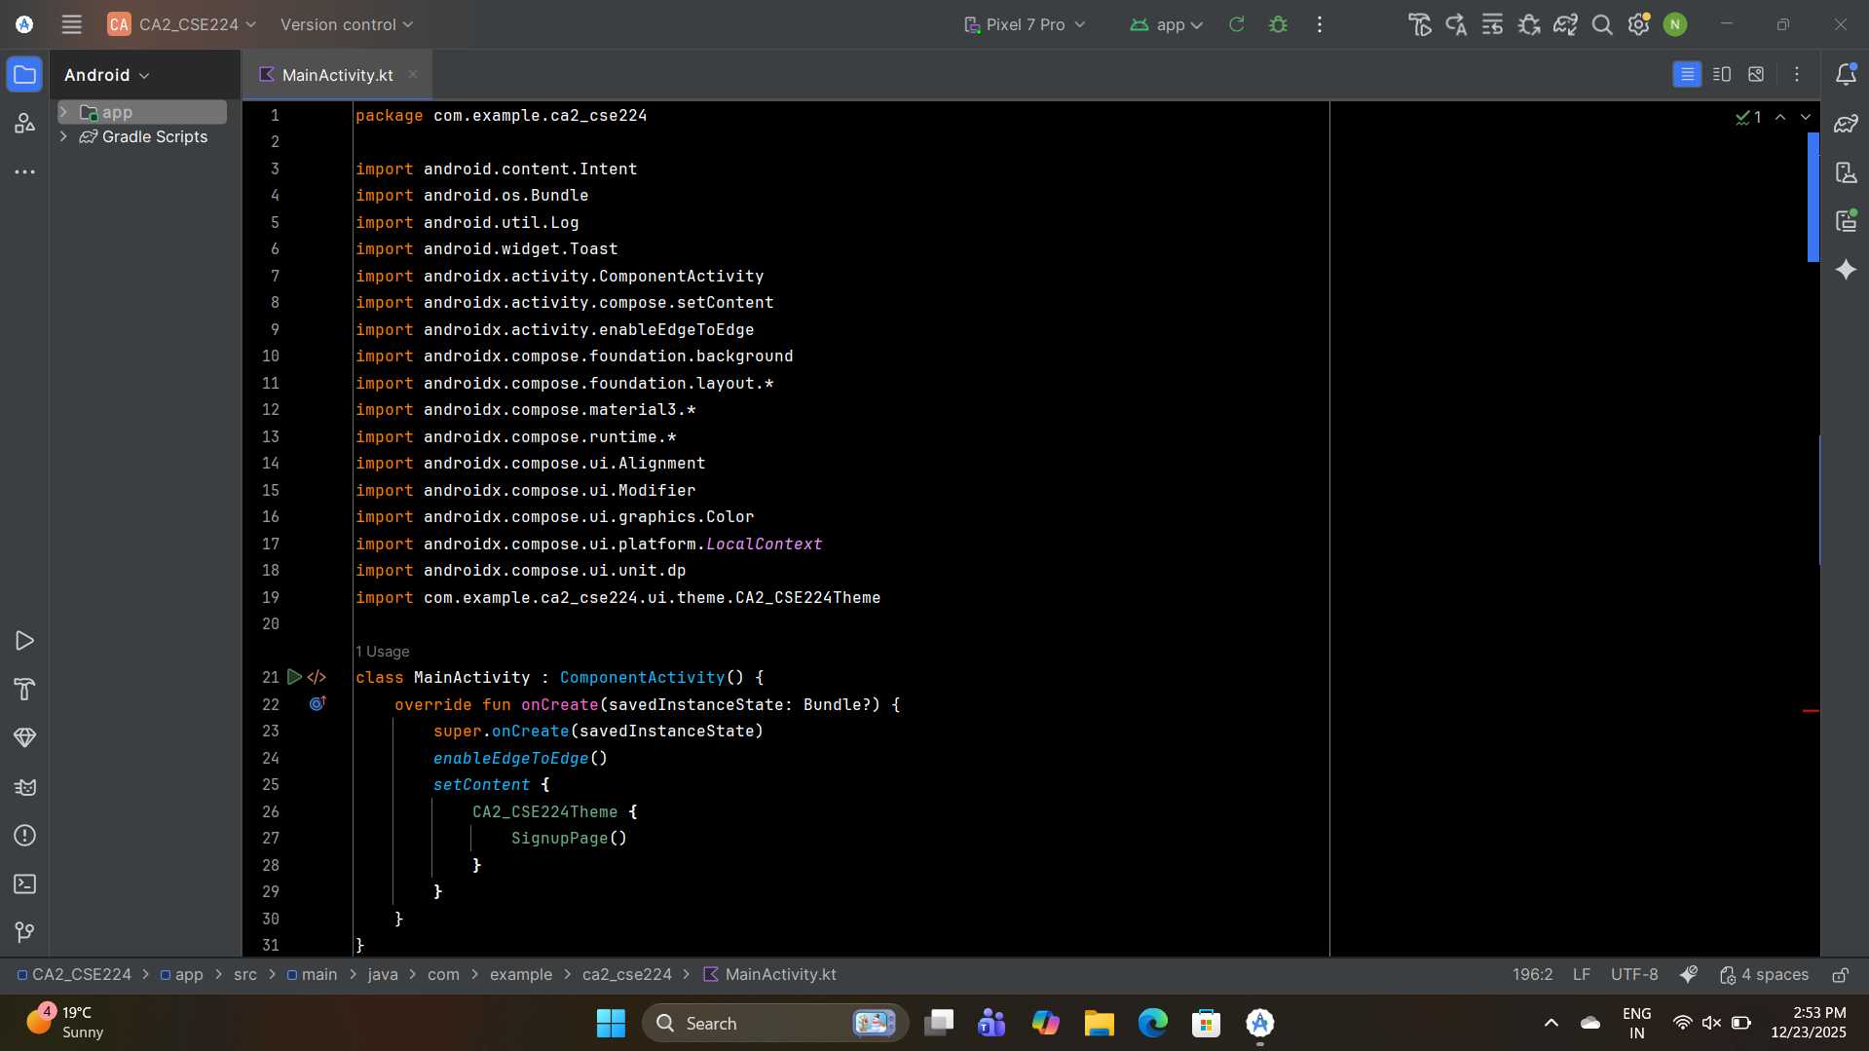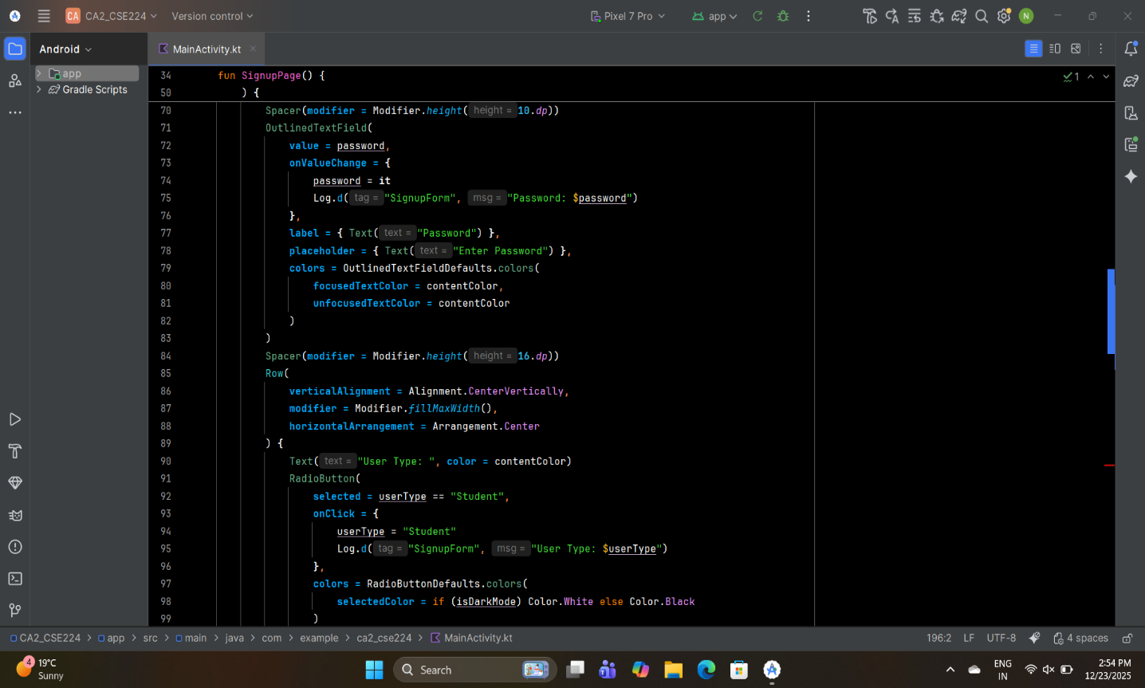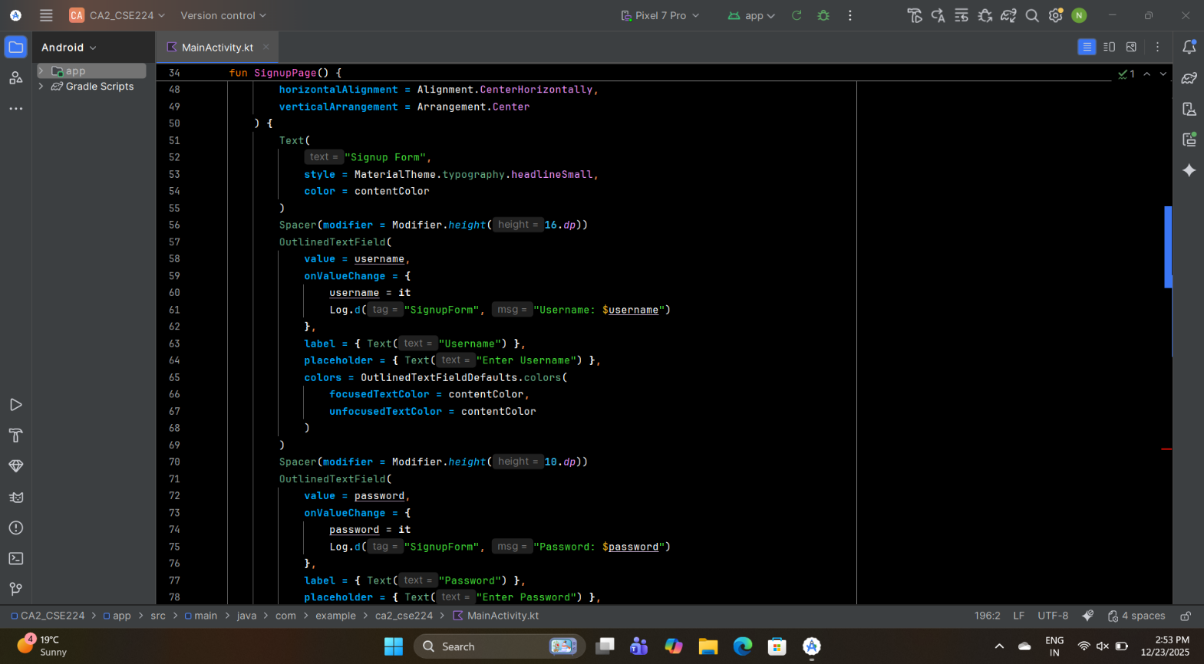

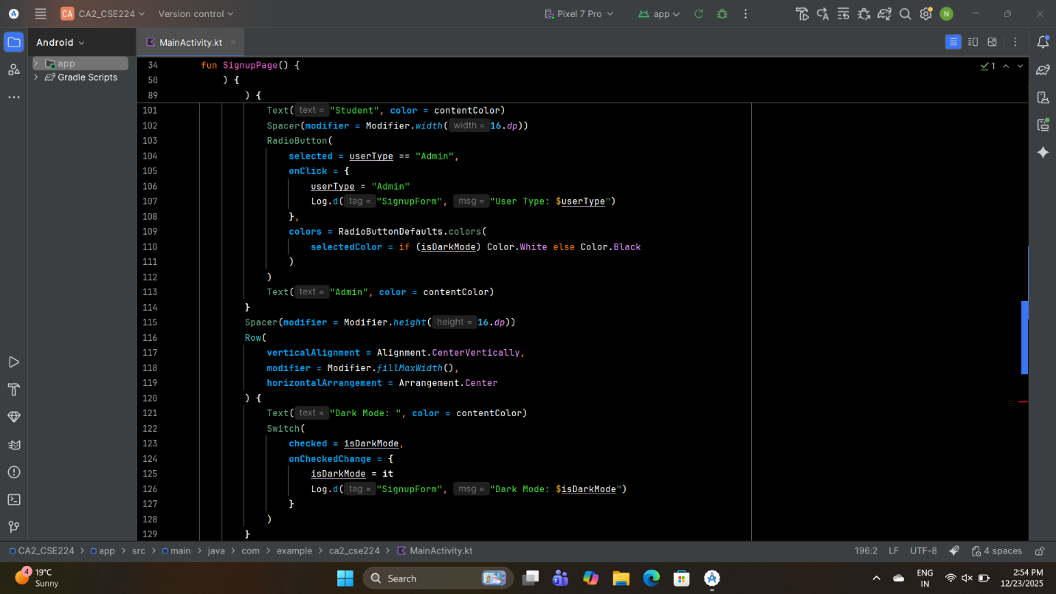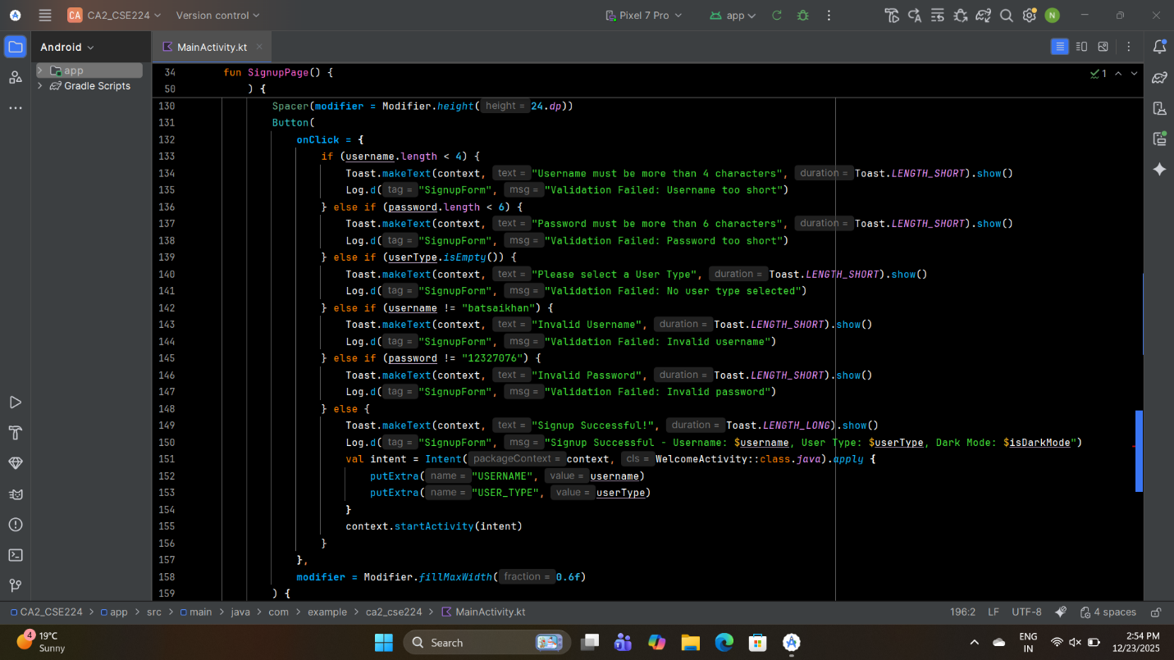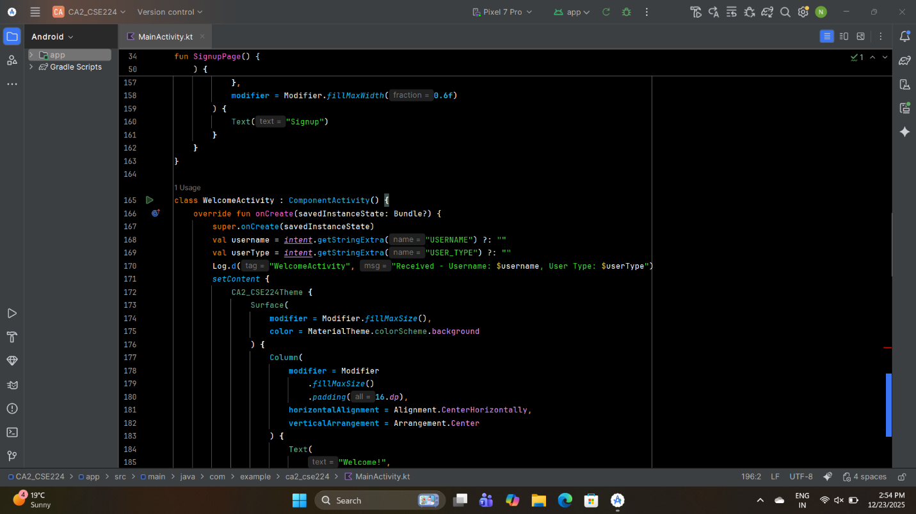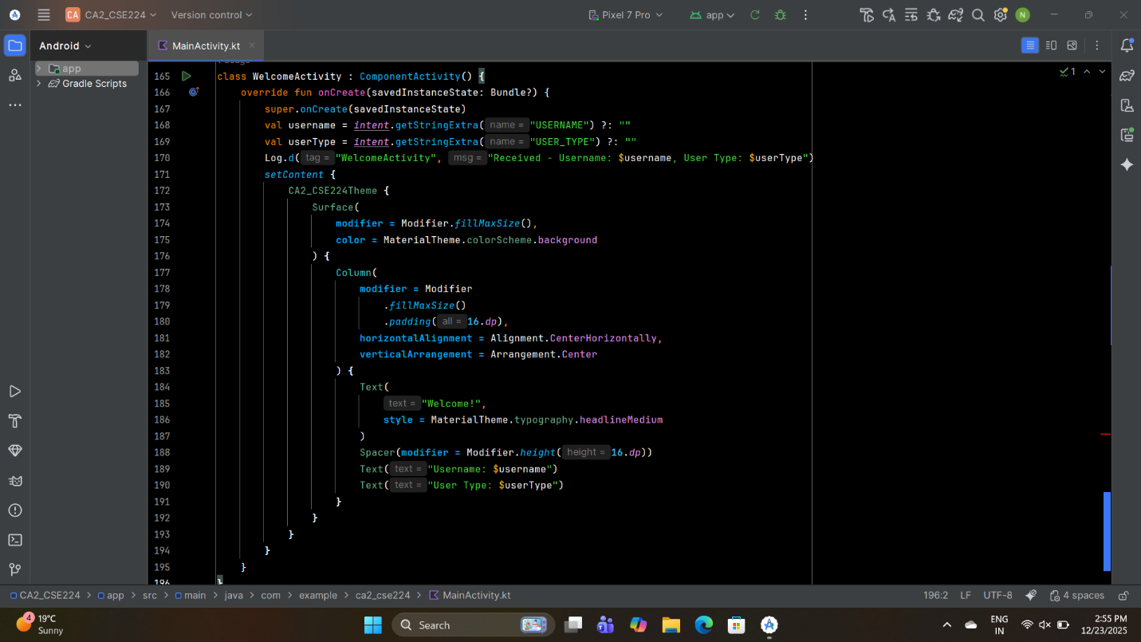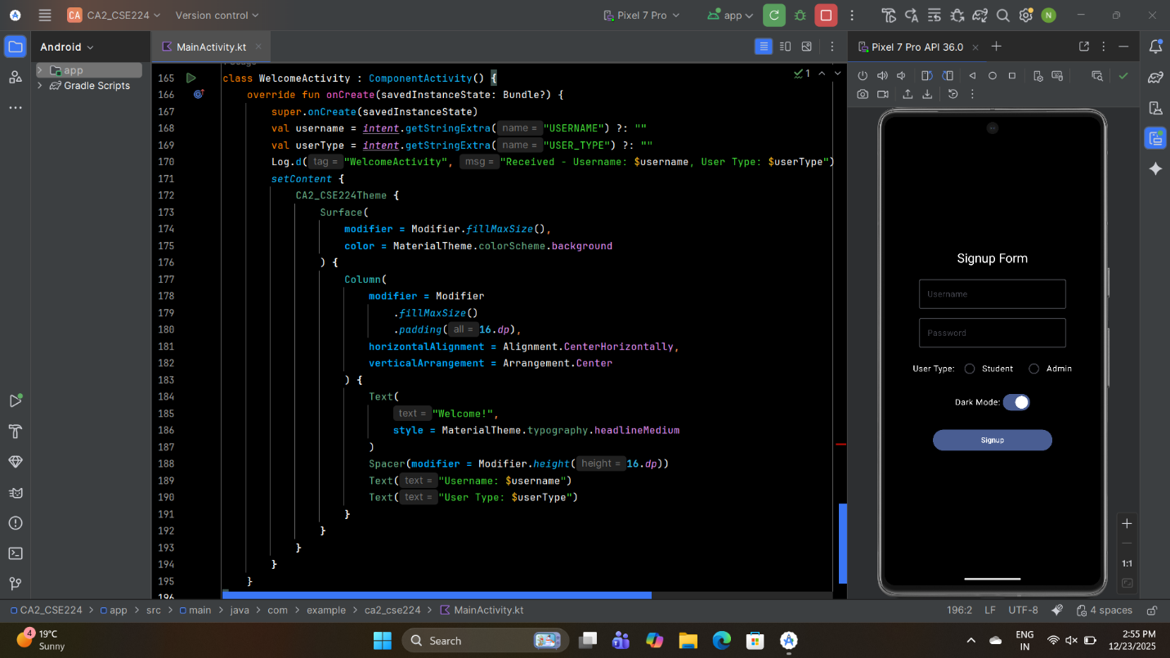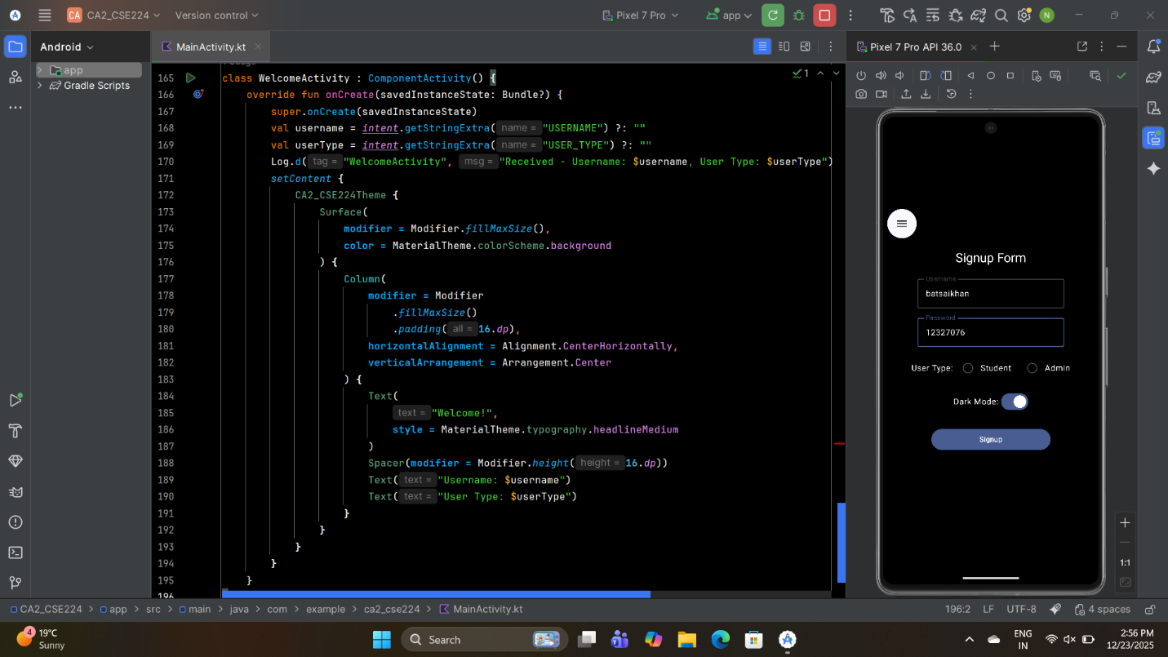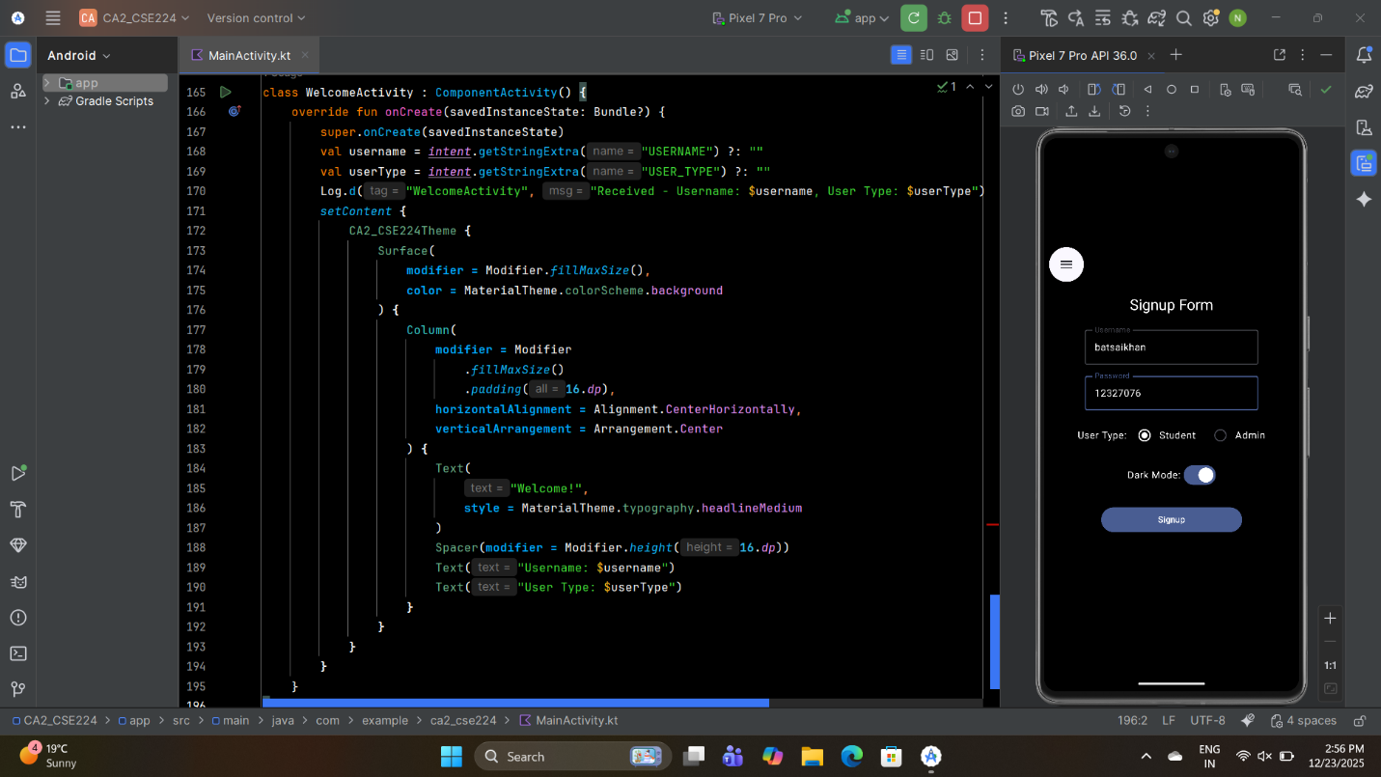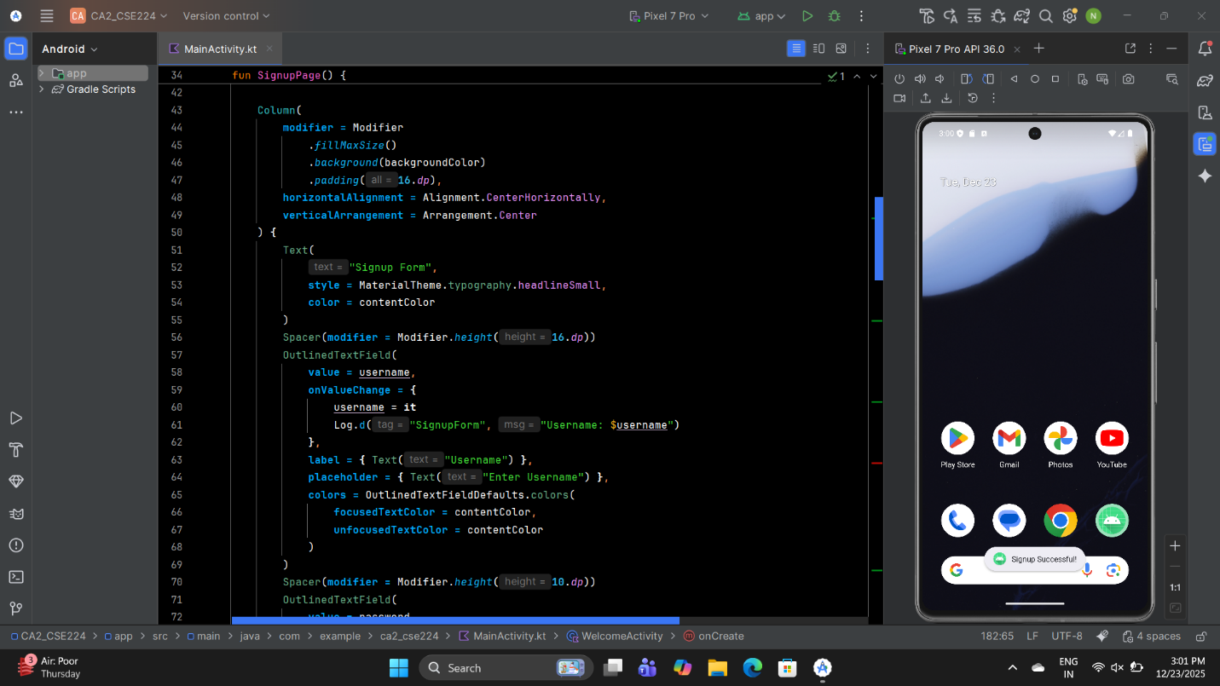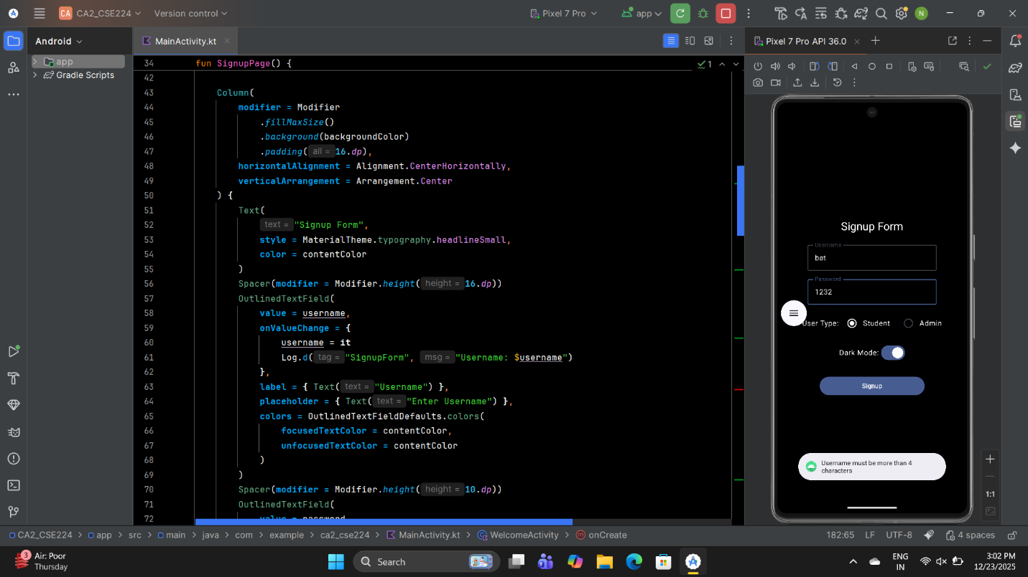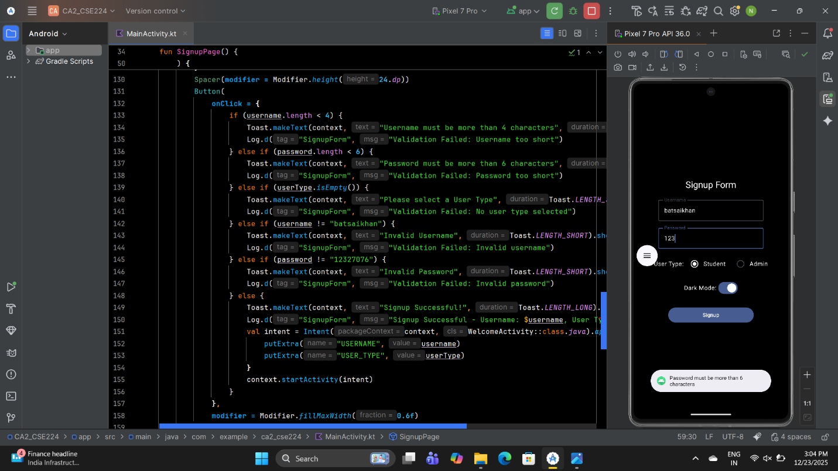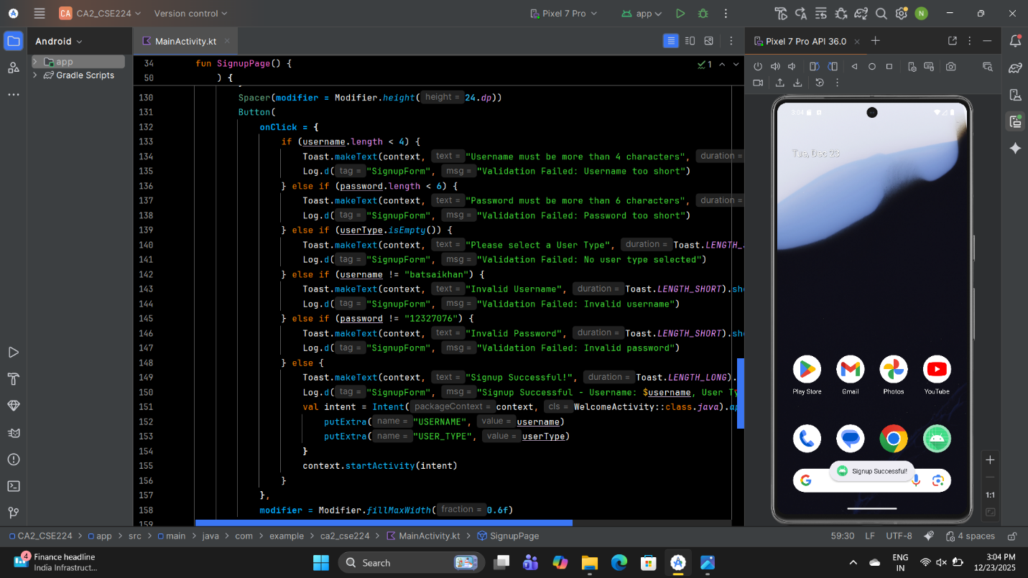

The output is:

